


DATE:

11/05/2026

To
ALAN BIJO VARGHESE

Enroll: - 2241230265

lnternship- Offer Letter

Dear ALAN BIJO VARGHESE , we are pleased to offer you internship at Vibrant Technology in the domain of Data Science. Your internship will be from 11/05/2026 to 11/08/2026 with flexible timings. During this period, you will gain practical experience through live projects and guidance from our mentors. This internship is for training purposes.

I welcome to you on the behalf of Vibrant Technology.
I hope you will find Vibrant Technology. as a place to Best work

Regards,
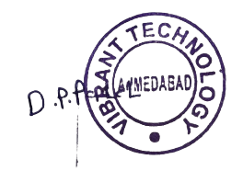
'
Team Leader



info@vibrantwebtech.in

+91 8511110213

801, Silicon Tower, Law Garden, opp. Axis Bank, Ellisbridge,
Ahmedabad, Gujarat 380006

